**Assessment for QA specialist - EHR Rev Transaction Ingestion**

**Task 1: Data Analysis Using Excel/Google Sheets.**

**Goal 1: Finding the associated provider for billing data using appointment data.**

At first, I am creating new column manually in a **scheduling_data** table of excel sheet.

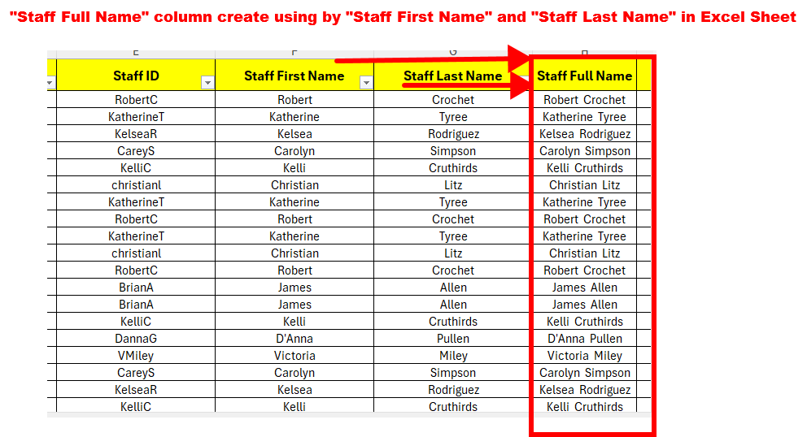

Then I am adding new column (provider_full_name) in a **billing_data** table using MySQL Database.

**SQL Command:**

**ALTER TABLE** billing_data **ADD COLUMN** provider_full_name **VARCHAR(255);**

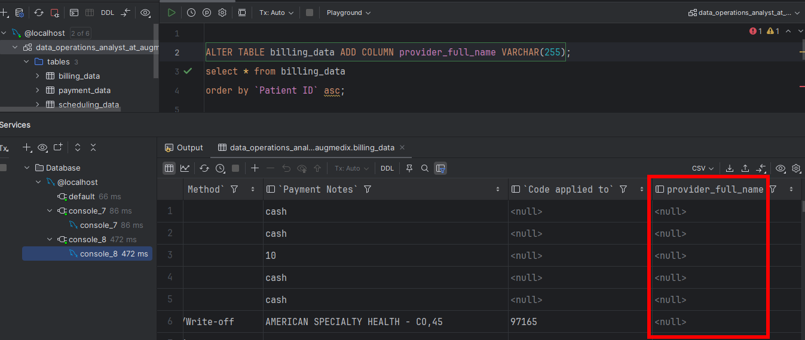

Then,

* I am used to MyQL JOIN between the scheduling_data and billing_data table.
* UPDATE billing_data table.
* CONCAT using Staff First Name and Staff Last Name.
* SET value in a provider_full_name

**SQL Command:**

**CONCAT**(scheduling_data.`Staff First Name`,' ', scheduling_data.`Staff Last Name`)

**(UPDATE** billing_data **JOIN** scheduling_data **ON** billing_data.`Patient ID` = scheduling_data.`Patient ID` **AND** billing_data.DOS = scheduling_data.`Appointment Start Date` **SET** billing_data.provider_full_name = **CONCAT**(scheduling_data.`Staff First Name`,' ', scheduling_data.`Staff Last Name`) **WHERE billing_data.provider_full_name ASC);**

**SQL Command:  
SELECT** provider_full_name **FROM** billing_data**;**

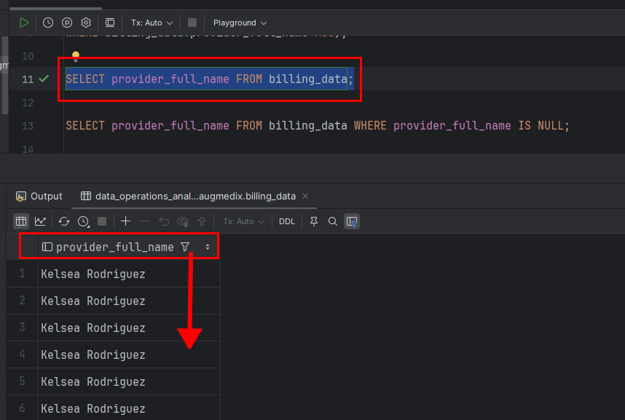

**SQL Command:**

**SELECT * FROM** billing_data **WHERE** provider_full_name **IS NULL;**

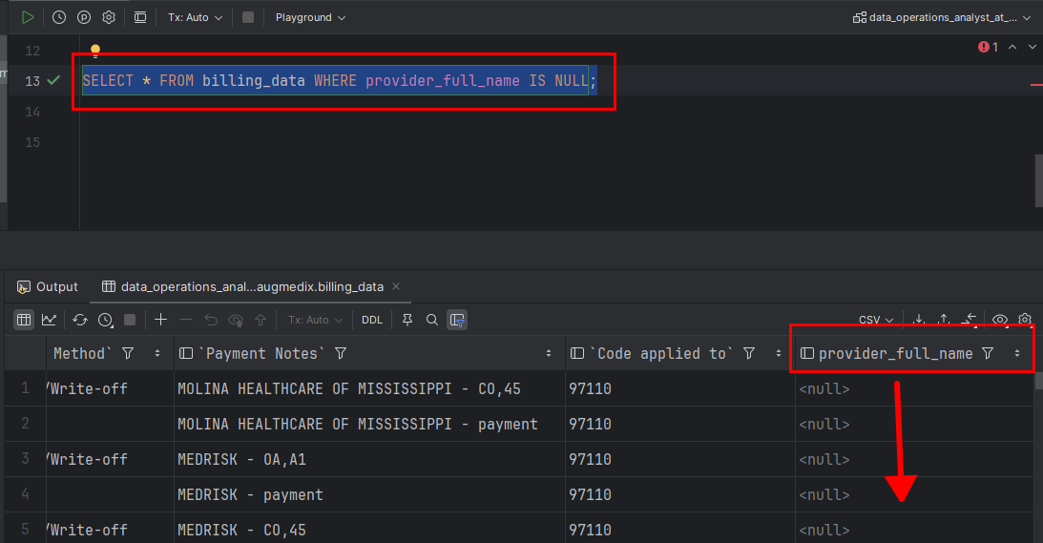

**Goal 2: Calculating Total Amount Collected Per Provider**

**SQL Command:**

**SELECT** provider_full_name, ***SUM***(Amount) **AS** total_amount_collected **FROM** billing_data **WHERE** `Payment Method` **IN** ('Cash', 'Check', 'EFT', 'Credit Card', 'Visa', 'Mastercard', 'AMEX') **GROUP BY** provider_full_name **ORDER BY** total_amount_collected **DESC;**

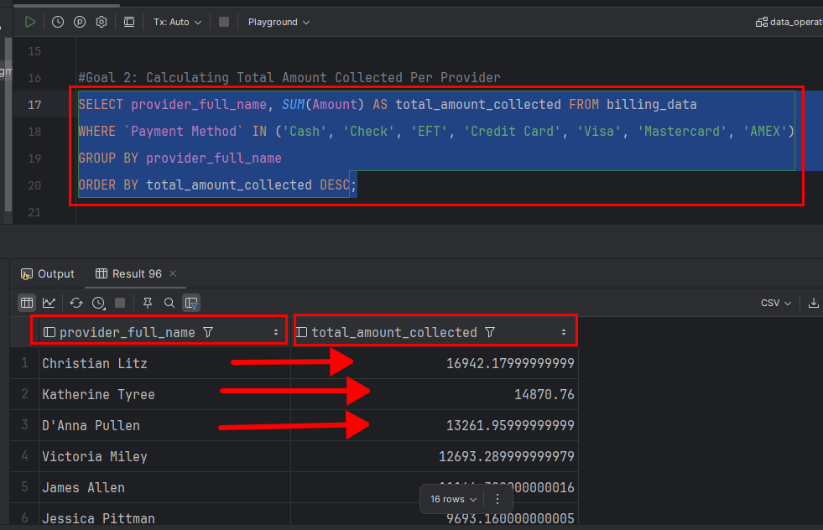

**Explanation:**

1. **Filters out non-revenue payment methods**
   * Excluded: 'Adjustment/Write-off', 'Check Refund' (since they do not contribute to revenue).
   * Included: 'Cash', 'Check', 'EFT', 'Credit Card', 'Visa', 'Mastercard', 'AMEX'.
2. **Calculates total revenue for each provider**
   * Uses SUM(Amount) to compute total revenue for each provider_full_name.
   * Groups by provider_full_name.
   * Orders by total revenue in descending order.

**Goal 3: Counting the distinct encounters in the billing data**

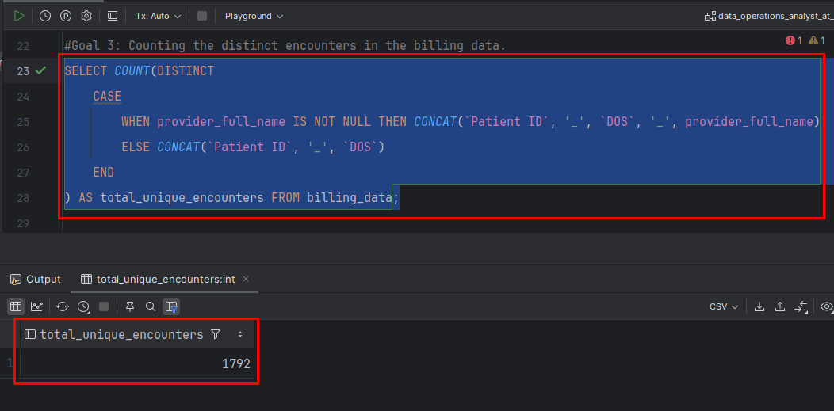

**Explanation**

Encounters are defined as unique combinations of:

* Patient ID
* Date of Service (DOS)
* provider_full_name.

If provider_full_name is NOT NULL, the encounter is identified by Patient ID, DOS, and provider_full_name.

If provider_full_name is NULL, the encounter is identified by Patient ID and DOS only.

Using DISTINCT and COUNT Functions.

**Task 2: RCM Data Analysis Assessment**

**Goal 1: Calculating total collections using claim level dataset provided in payment_data**

I did data cleaning and transformation on my payment_data table. Adding billing data and payment data, where the claim ID was matching and the CPT codes were partially matching.

**Total Amount Collected**:

**SQL Command:**  
**SELECT *SUM***(Amt) AS total_amount_collected **FROM** payment_data;

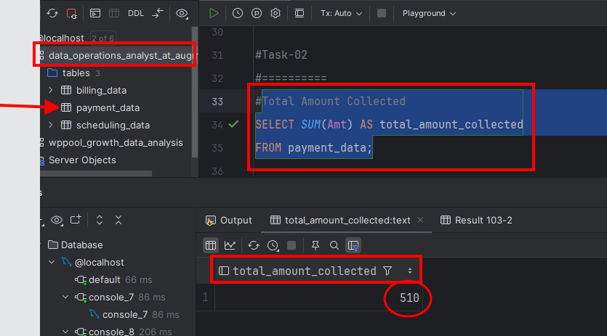

**Breakdown by Payment Source**:

**SQL Command:**

**SELECT** `Source of Payment`, ***SUM***(Amt) **AS** amount_collected **FROM** payment_data **GROUP BY** `Source of Payment`;

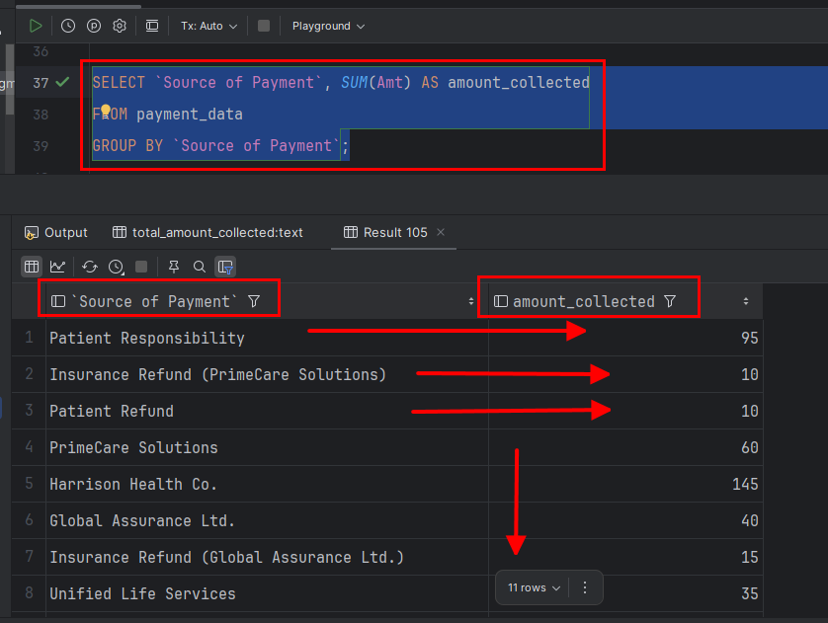

This groups collections by **Primary Insurance, Secondary Insurance, and Patient Responsibility**.

**Average Amount Collected Per Encounter**:

**SQL Command:**

**SELECT *AVG***(total_collected) **AS** average_amount_per_encounter **FROM (  
 SELECT** `Claim ID`, ***SUM***(Amt) **AS** total_collected **FROM** payment_data **GROUP BY** `Claim ID` **) AS** encounter_totals;

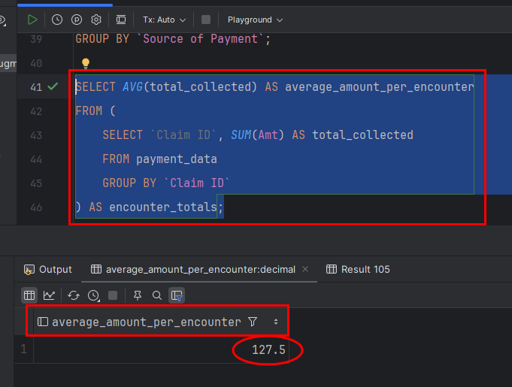

* + - First, it groups by Claim ID to get total revenue per encounter.
    - Then, it calculates the average revenue per unique encounter.

**Goal 2: Primary and Secondary Insurance Analysis**

**Average Amount Collected Per Encounter**:

**SQL Command:**

**SELECT** `Insurance Type`, `Insurance Name`, ***AVG***(total_collected) **AS** avg_collected_per_encounter **FROM (  
 SELECT** 'Primary' **AS** `Insurance Type`, `Primary Insurance` **AS** `Insurance Name`, `Claim ID`, ***SUM***(Amt) **AS** total_collected **FROM** payment_data **GROUP BY** `Primary Insurance`, `Claim ID` **UNION ALL  
 SELECT** 'Secondary' **AS** `Insurance Type`, `Secondary Insurance` **AS** `Insurance Name`, `Claim ID`, ***SUM***(Amt) **AS** total_collected **FROM** payment_data  
 **GROUP BY** `Secondary Insurance`, `Claim ID`  
**) AS** insurance_totals  
**GROUP BY** `Insurance Type`, `Insurance Name`  
**ORDER BY** avg_collected_per_encounter **DESC  
LIMIT 1;**

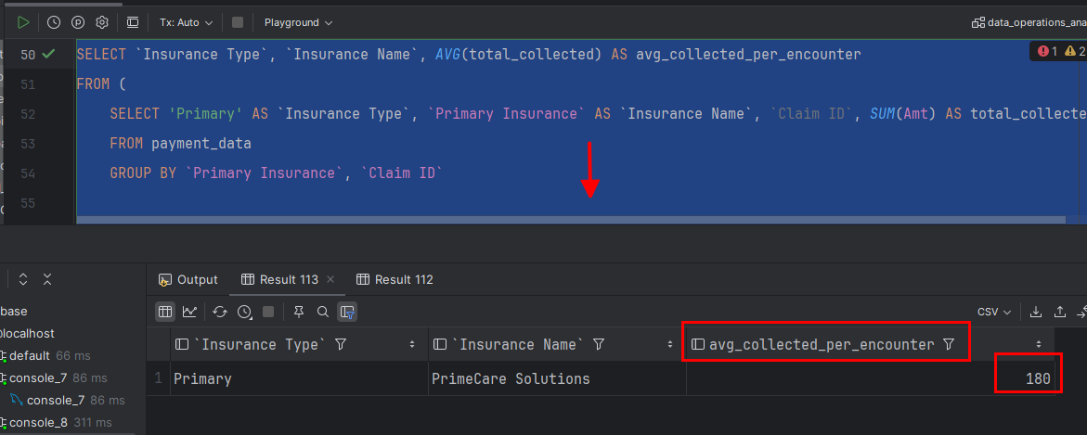

**Average Amount Collected Per Encounter**:

**SQL Command:**

**SELECT** `Insurance Name`, ***SUM***(Amt) **AS** total_collected **FROM (  
 SELECT** `Primary Insurance` **AS** `Insurance Name`, Amt **FROM** payment_data **UNION ALL  
 SELECT** `Secondary Insurance` **AS** `Insurance Name`, Amt **FROM** payment_data  
**) AS** insurance_totals **WHERE** `Insurance Name` **IN** ('Harrison Health Co.', 'PrimeCare Solutions', 'National Coverage Group') **GROUP BY** `Insurance Name`;

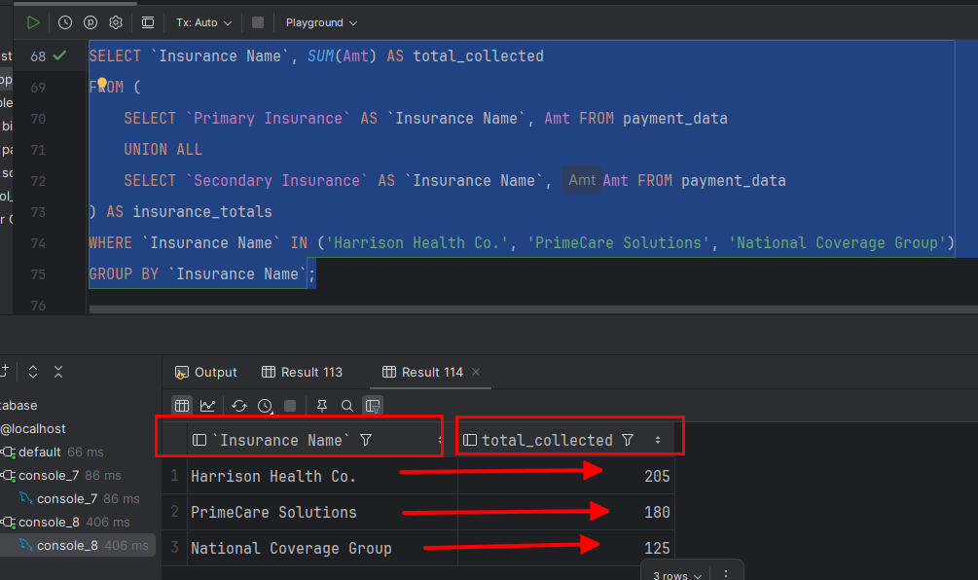

**Goal 3: Understanding the basics of revenue cycle management**

**1. Claim Submissions:**

Claim submission is the process of sending healthcare claims to insurance providers for reimbursement of medical services. It ensures that healthcare providers receive payment for services rendered.

**Key Steps in Claim Submission:**

* **Patient Registration & Insurance Verification**
* Collect patient details, insurance coverage, and eligibility.
* Ensure accuracy in policy details to prevent denials.
* **Medical Coding & Charge Entry**
* Convert diagnoses and procedures into standardized medical codes (CPT, ICD-10, HCPCS).
* Ensure that services are correctly billed based on documentation.
* **Claim Creation & Review**
* Populate claim forms (CMS-1500 for outpatient, UB-04 for inpatient).
* Validate against payer-specific rules for compliance.
* **Claim Submission to Payers**
* Submit claims electronically via clearinghouses (EDI transactions).
* Direct submission to insurers when applicable.
* **Payer Acknowledgment & Processing**
* Insurer receives and validates the claim.
* Claim is either approved, denied, or returned for corrections.

**2. Claim Reconciliation**

Claim reconciliation is the process of matching insurance payments with billed amounts to ensure accurate revenue capture and identify discrepancies.

**Importance of Claim Reconciliation:**

* Prevents revenue leakage due to underpayments or missing payments.
* Ensures correct payment posting against claims.
* Helps in timely appeals and dispute resolutions for incorrect payments.

**Key Steps in Claim Reconciliation:**

* **Payment Posting**
* Match payments received (EFT, checks) with claims in the billing system.
* Identify underpayments, overpayments, and unpaid claims.
* **Remittance Advice Review**
* Analyze Explanation of Benefits (EOB) or Electronic Remittance Advice (ERA).
* Verify allowed amount, adjustments, and denials.
* **Discrepancy Identification**
* Compare expected vs. received payments.
* Investigate partial payments, missing claims, and incorrect adjustments.
* **Resolution & Resubmission**
* Contact payers for payment discrepancies.
* Resubmit claims if errors are found.
* Apply necessary adjustments or refunds.

**3. Claim Denials**

Claim denials occur when insurance companies refuse to reimburse a healthcare provider due to errors, missing information, or policy-related reasons.

**Common Reasons for Claim Denials:**

* Coding Errors – Incorrect CPT/ICD-10 codes, mismatched procedures and diagnoses.
* Incomplete Information – Missing patient demographics, authorization numbers, or provider details.
* Duplicate Claims – Same claim submitted multiple times.
* Eligibility Issues – Expired insurance, coverage limits, or service exclusions.
* Timely Filing Limits – Claims submitted after the payer’s deadline.

**Denial Management Strategies:**

* **Denial Tracking & Root Cause Analysis**
* Categorize denials by type and frequency.
* Identify patterns to implement preventive measures.
* **Claim Appeal Process**
* Gather supporting documents (medical records, authorization).
* Submit corrected claims with justification.
* Follow up with insurers to ensure resolution.
* Process Improvement & Automation
* Use claim scrubbers to detect errors before submission.
* Automate eligibility verification and prior authorizations.
* Train billing staff on compliance and best practices.

**Data Visualization using Power BI tools:**

